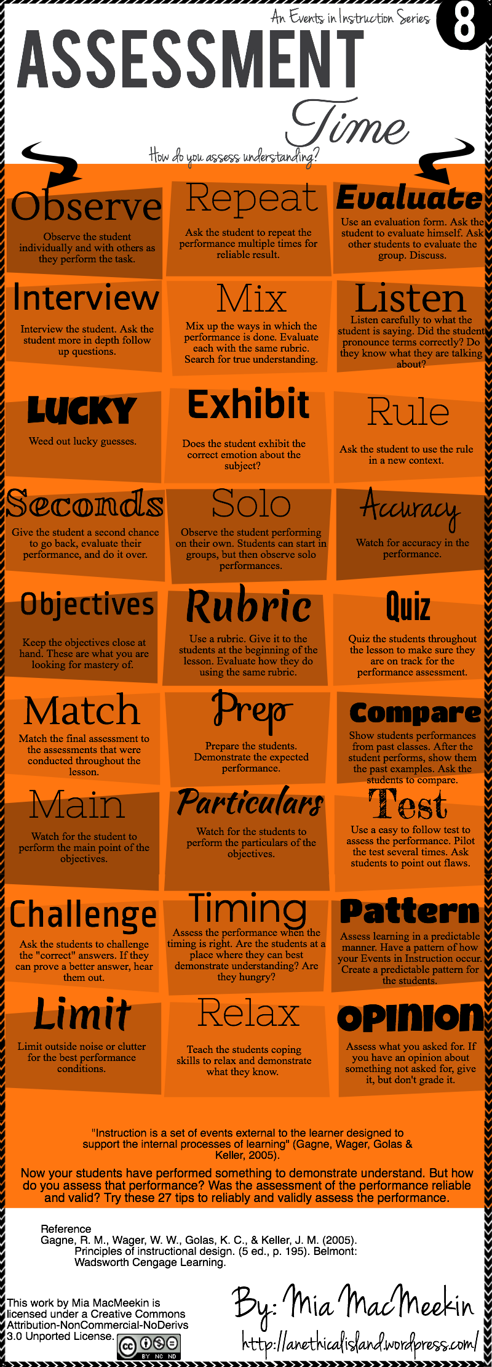
http://elearninginfographics.com/how-can-teachers-assess-students-understanding-infographic/

Assessment: How Can Teachers Assess Students’ Understanding Infographic?
I chose the infographic for an assessment to explain the ADDIE model that the designers used. In this infographic, there are several methods and ways that the developers have used to write the details of the infographic. Those details of the graphic were based on a basic model that the developers write to describe their project to the learners, which is ADDIE model.
In the analysis phase, the designers used an interview that the instructor asks students some questions. A focus group was used to make an exhibit their emotion when they talk about the subject. Observing some student's performance individually when they did the task. Also, listening to the students if they pronounce the term correctly and know what they are talking about.
The design phase is what the designer able to apply the product visually by using some graphics to make the designer establish the lesson plan, media selection, and other materials. The developers used many ways in this infographic to assess students understanding. First, a prototype was used during this phase when the designer used the rubric to make students know how they are going to be evaluated by their instructor in the lesson. Second, the designers used the preparing to demonstrate student’s performance. Moreover, having objectives and patterns are helpful when the events of the instruction happened. This phase leads us to do the next step, which is the development phase.
In the development phase, the designer develops the product and reviews it to avoid any possible error before the next phase. The developer used graphic to define students’ understanding in this infographic. Repeating the student’s performance, multiple times is used for better results. Also, seconds and solo are two factors that the instructor help students and give them a chance to evaluate their performance whether if it individual or groups. In addition, match the final assessment is used to the assessment that the instructor had used when they conducted their project.
The implementation phase is the place the developer use steps and different tools for training. In this phase, the designers mix up the ways to see how much the performance is done. Also, asking students to put rule in a new context. Furthermore, accuracy and comparison are used in this phase to see the last errors and fix them. So, after the implementation we will go to the last phase, which is the evaluation.
In the evaluation phase, the designers used both formative and summative evaluation to assess students understanding. In the formative evaluation, the designers evaluate students understanding by using a quiz, test, and timing. For the summative evaluation, the developers use the opinion to give students feedback about their performance and understanding.
In conclusion, this was a detailed explanation that I wrote by using ADDIE model about the infographic that the designers create to assess students understanding. Hence, I believe that this graphic has useful information for those who like to get some steps or instruments about this evaluating learner performance and understanding.

